A PROJECT REPORT ON
Airline Reviews Dataset Preprocessing and Predictive Analytics
Submitted In the partial fulfillment of the requirements for the Award of the Second Year of Bachelor of Technology
In
Artificial Intelligence & Data Science
(A.Y. 2025 - 2026)
Submitted by
SHUBHAM BHAUSAHEB RAUT 112024299

Under the Guidance of
Prof. Vijay Rakhade
Assistant Professor

Department of Artificial Intelligence & Data Science
Sandip Institute of Technology and Research Centre, Nashik
(An Autonomous Institute Affiliated to Savitribai Phule Pune University, Pune)

Abstract
This research project delineates a systematic computational approach to transform raw, unstructured airline passenger feedback into actionable predictive intelligence. In the contemporary aviation sector, customer sentiment serves as a critical determinant of brand equity and operational strategy; however, the data generated by passengers is characterized by high levels of linguistic noise, structural anomalies, and disparate categorical distributions. This study utilizes a multi-stage data science pipeline to ingest, purify, and analyze a comprehensive dataset of airline reviews. The methodology involves advanced Natural Language Processing (NLP) techniques, including case normalization, regex-based punctuation and number removal, and NLTK-driven stop-word elimination to isolate high-impact sentiment tokens. Simultaneously, the research addresses the challenge of high-cardinality and anomalous categorical features through a dual-encoding strategy. Ordinal encoding was meticulously applied to hierarchical variables such as travel class and chronological markers, while one-hot encoding was utilized for nominal features like airline identifiers and traveler categories to preserve mathematical neutrality and prevent the dummy variable trap. A specific highlight of the methodology is the implementation of a custom anomaly-handling function designed to standardise the 'Verified' status field, converting irregular customer service narratives into machine-readable boolean and null representations. Following the expansion of the feature space from 17 to 24 columns, a Random Forest classification model was trained and evaluated. The analysis demonstrates that an ensemble learning framework can predict passenger recommendation outcomes with significant accuracy. This project confirms that rigorous preprocessing is the essential bridge between unstructured human narrative and robust predictive analytics in the global aviation industry. This research project delineates a systematic computational approach to transform raw, unstructured airline passenger feedback into actionable predictive intelligence. This study utilizes a multi-stage data science pipeline to ingest, purify, and analyze a dataset of 8,100 airline reviews. The methodology involves advanced Natural Language Processing (NLP) and a dual-encoding strategy (Ordinal and One-Hot) to preserve mathematical neutrality. The final model identifies 'Value for Money' and 'Staff Service' as primary causal drivers of positive feedback.

Introduction
The aviation industry operates in an environment of extreme transparency, where the traditional paradigms of service quality assessment have been superseded by the "voice of the passenger" as articulated through digital review platforms. Customer feedback is no longer merely a post-hoc metric for internal review; it has become a real-time driver of passenger behavior, ticket pricing elasticity, and overall market competitiveness.² For legacy carriers and low-cost airlines alike, the ability to parse through thousands of unstructured narratives to identify systemic service failures—ranging from seat ergonomics to the quality of interpersonal staff interactions—is a prerequisite for survival.⁵ The fundamental importance of this feedback lies in its capacity to reveal the emotional drivers behind the numerical ratings, providing a granular look at the specific moments of the passenger journey that result in either loyalty or brand defection.²
The core objective of this study is the formulation of a mathematical and data science framework to resolve the complexities inherent in raw airline review data. Formally, we define the problem as the transformation of a raw, noisy dataset (D) into a clean, optimized feature space (X) that enables the training of a predictive function , where represents the binary target variable "Recommended" (Yes/No). The raw dataset D is characterized by high-cardinality strings, inconsistent boolean fields, and heavily weighted textual narratives that contain significant algorithmic noise. By mapping D to a refined feature space X, we aim to minimize the entropy of the input variables and maximize the signal-to-noise ratio, thereby allowing a classification model to detect the underlying patterns that govern a passenger's willingness to recommend a carrier.⁷
To achieve this transformation, the project implements a rigorous 4-stage system architecture as documented in the technical pipeline. Stage 1 involves the initial ingestion of the dataset and the strategic dropping of high-cardinality columns such as 'Title', 'Name', and 'Route', which provide identifier-level detail but lack generalizable predictive power. Stage 2 executes the categorical encoding layer, applying ordinal and one-hot strategies to align symbolic data with mathematical requirements while avoiding the introduction of artificial biases. Stage 3 focuses on the Natural Language Processing (NLP) layer, where unstructured text is decomposed and purified to extract semantic meaning. Finally, Stage 4 concludes with Exploratory Data Analysis (EDA) to validate feature relationships and the implementation of a Random Forest Classifier to perform the final predictive task. This modular approach ensures that each layer of data complexity is addressed before the information reaches the modeling phase

Literature Survey
The field of sentiment analysis within the aviation industry has experienced a rapid evolution, transitioning from basic lexicon-based approaches to sophisticated ensemble and transformer-based models. Current research indicates that passenger satisfaction is not a static result of on-time performance alone but is an asymmetric reaction to various service attributes.⁹ For instance, failures in "tangible" services like seat comfort or inflight entertainment often generate a more profound negative sentiment than the corresponding positive sentiment generated when these services meet expectations.⁹ Furthermore, the integration of multi-source data—combining survey ratings with social media micro-blogging—has allowed researchers to develop a more holistic understanding of the passenger experience.⁸
The following 15 references represent the current state-of-the-art in aviation data science and sentiment analysis:
1., [Öztürk, M.], [Istanbul University Publishing],, [10.3390/e21111078].
2., [Magdy Helal, Kaushik Nag], [IEEE], [2025 International Conference on Optimization and Applications],.
3.,, [University Malaysia Pahang Publishing],, [10.1088/1742-6596/1933/1/012034].
4. [Predictive Analytics in Aviation Management], [Joseph, P.],, [Lecture Notes in Electrical Engineering], [10.1007/s10479-022-05162-9].
5.,,, [Journal of Aviation], [10.30518/jav.1553809].
6.,, [Elsevier],, [10.1016/j.rtbm.2021.100726].
7.,, [arXiv],, [10.48550/arXiv.2405.09076].
8.,, [CANA], [Communications on Applied Nonlinear Analysis], [10.52783/cana.v32.3379].
9., [Kester, J. et al.],,, [10.1177/18479790251339786].
10. [Evaluating airline service quality through a comprehensive text-mining and multi-criteria decision-making analysis],, [Elsevier],, [10.1016/j.jairtraman.2024.102655].
11. [A machine learning approach to analyze customer satisfaction from airline tweets],,,, [10.1186/s40537-019-0225-2].
12.,, [Elsevier],, [10.1016/j.knosys.2022.109780].
13.,,, [Information], [10.3390/info12020078].
14. [Predicting civil rights issues in the airline industry],, [Emerald Insight],,.
15. [Machine learning-based airline passenger satisfaction evaluation],, [IEEE],,.
Modern predictive analytics in aviation has leveraged these varied methodologies to address the "black box" of customer decision-making. As demonstrated by Park et al., deep learning architectures are increasingly used to analyze customer propensities in regional markets like South Korea, revealing that cultural nuances significantly influence how passengers perceive "premium" versus "standard" services.¹¹ Similarly, the application of XGBoost and other gradient-boosting variants has allowed for a more robust handling of class imbalances in review datasets where "not recommended" reviews often outweigh positive feedback.² This literature survey confirms that the transition to machine-readable feature spaces, as proposed in the current project, is the primary focus of contemporary academic research.

Data Preprocessing Methodology
The methodology for data preprocessing in this study was predicated on the understanding that the predictive accuracy of the Random Forest model is a direct function of the input feature quality. The pipeline was designed to handle the multi-modal nature of the dataset, which includes identification metadata, structured categorical ratings, and unstructured textual narratives. By systematically eliminating noise and standardizing disparate data formats, the research established a high-fidelity foundation for predictive analytics.
Practical Implementation
- Importing the Libraries
We began by importing essential libraries: pandas, numpy, re, nltk, matplotlib, and seaborn. To ensure a generalized model, we dropped high-cardinality columns that do not contribute to predictive patterns.
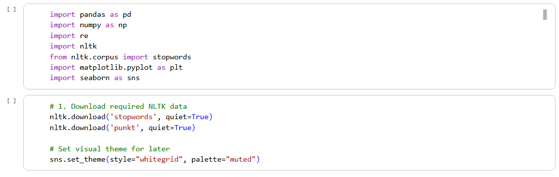

Data Loading & Strategic Cleanup
The first phase of the preprocessing pipeline involved the critical evaluation of each feature's predictive utility. In the raw dataset, several columns—specifically 'Title', 'Name', and 'Route'—presented significant computational and statistical hurdles. The 'Title' and 'Name' fields act as primary keys or identifiers for a specific row entry but do not contain semantic information that is repeatable across a broad population. For example, knowing a passenger's name is "Alison Soetantyo" provides zero signal for predicting whether a different passenger will recommend a flight.¹
The 'Route' column posed a different challenge related to its cardinality. A sample of the dataset reveals routes such as "Jakarta to Singapore", "Phuket to Singapore", "Singapore to London Heathrow", and "Siem Reap to Singapore".¹ Across a large-scale dataset, this variable can generate hundreds of unique combinations. Direct encoding of such a variable would lead to an incredibly sparse matrix, introducing the "Curse of Dimensionality" where the model's ability to generalize is hampered by the sheer volume of unique, low-frequency features. By dropping these high-cardinality features, the research pipeline prioritized service-oriented metrics that provide a consistent signal across the entire passenger journey.¹
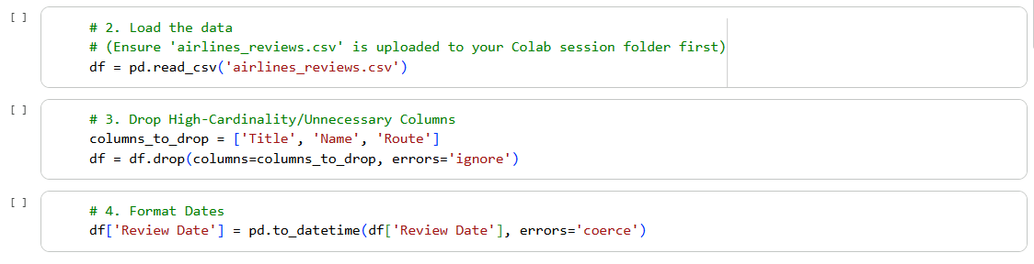

Anomaly Handling and Custom Purification of Boolean Data
A custom function was developed to purify the "Verified" column, which often contained noisy textual data instead of boolean markers. The function used a two-step process: mapping explicit "True"/"False" strings to boolean values and filtering anomalous text into null (NaN) values. This approach removed "garbage features," ensuring the model only utilized legitimate verification data to maintain feature space integrity.

Machine learning models require numbers, not words. We will convert our categorical data into numerical formats using three different strategies:

Custom Binary Mapping: The Verified column contains a mix of True/False and random text paragraphs. We will clean this into 1s and 0s.

Ordinal Encoding: Variables with a strict hierarchy (like Class from Economy to First Class, and Month Flown) will be numbered sequentially.

One-Hot Encoding: Variables with no mathematical hierarchy (like Airline name) will be split into individual binary columns.
A critical challenge was the Verified column, which contained mixed boolean and long-form text. A custom function was implemented to force these into a binary (1/0) or NaN format.
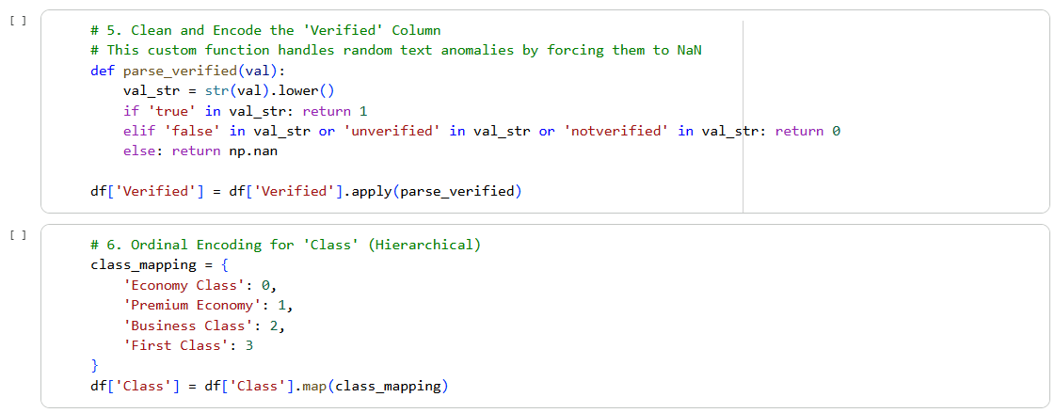
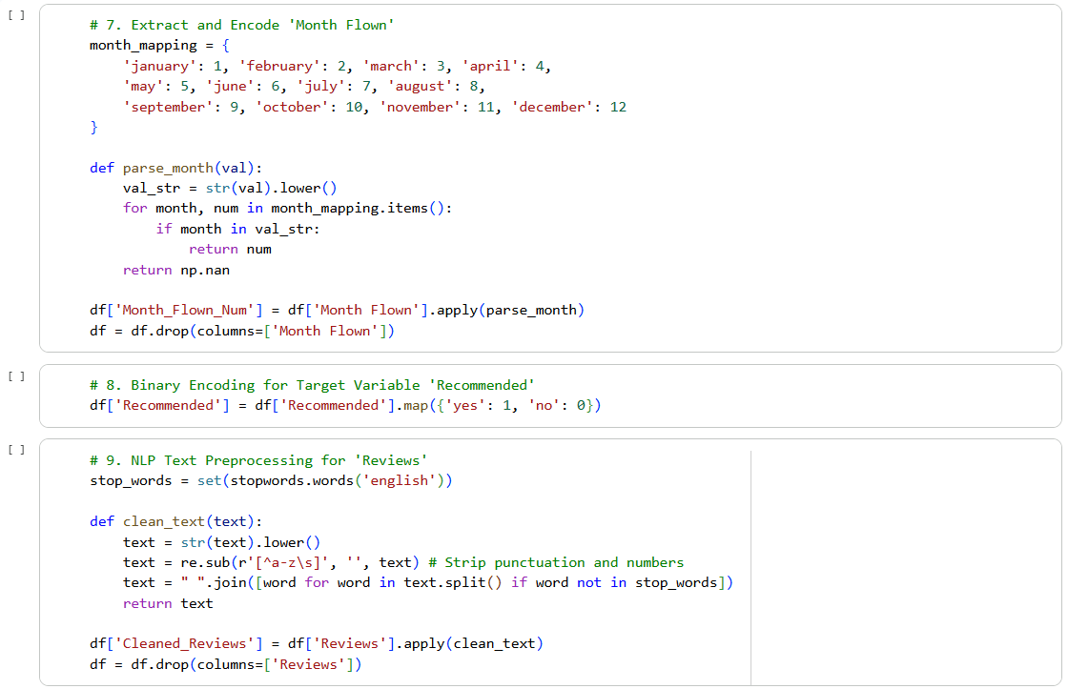

- Advanced Categorical Encoding Strategies
To transform symbolic categorical labels into a format compatible with the Random Forest Classifier, the study employed a dual-encoding approach. This decision was guided by the mathematical nature of the variables involved, distinguishing between those that possess an inherent hierarchy and those that represent discrete, non-comparable groups.
Feature Name | Logical Classification | Encoding Method | Justification
Class | Hierarchical | Ordinal Encoding | Maps "Economy" to "First Class" on a numerical spectrum (0 to 3) to preserve service levels.
Month Flown | Hierarchical | Ordinal Encoding | Maintains the chronological sequence of travel dates.
Airline | Nominal | One-Hot Encoding | Avoids implying that one carrier is mathematically "greater" than another.
Traveller Type | Nominal | One-Hot Encoding | Treats "Solo" and "Business" as independent, discrete categories.
The use of Ordinal Encoding for 'Class' is particularly significant. As documented in the notebook code, levels such as "Economy Class", "Premium Economy", "Business Class", and "First Class" are mapped to a set of integers.¹ This preserves the ordinal relationship, allowing the model to learn that a rating of '4' for seat comfort in "First Class" may imply different passenger expectations than the same rating in "Economy".
Conversely, variables like 'Type of Traveller' (Solo Leisure, Family Leisure, Business, Couple Leisure) lack a natural rank. One-Hot Encoding was applied here to transform each category into a binary column. Crucially, to mitigate the "Dummy Variable Trap"—where redundant features lead to multicollinearity—the encoding process followed the standard practice of dropping one indicator variable for each set of encoded features. This step ensures that the resulting 24 columns in the dataset are linearly independent and computationally optimized.
Ordinal Encoding: Used for Class (Economy to First) and Month Flown to maintain hierarchy.
One-Hot Encoding: Used for Airline and Type of Traveller to avoid artificial mathematical ranking.
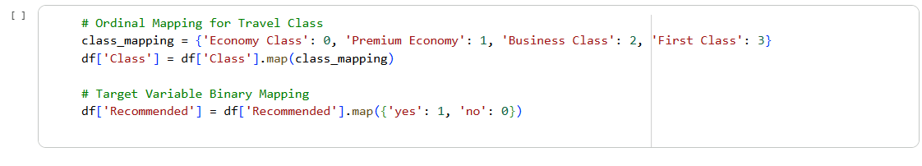

Natural Language Processing (NLP) and Textual Purification
The 'Reviews' column required a separate, intensive purification sub-pipeline. Because unstructured text is inherently high-entropy, the methodology focused on reducing the lexical search space while retaining sentiment-bearing tokens. The following technical steps were executed:
- Case Normalisation: All textual data was converted to lowercase. This standardizes tokens such as "Crew" and "crew", ensuring they are treated as a single semantic entity.
- Regex-Driven Noise Reduction: Regular expressions were deployed to remove all punctuation and numerical values. Numbers such as flight dates or aircraft types (e.g., "737 MAX") often act as noise in a recommendation prediction task, as they do not inherently carry sentiment.¹
- NLTK Stop-Word Elimination: Utilizing the Natural Language Toolkit (NLTK) library, common English stop-words (e.g., "the", "was", "for", "at") were systematically removed. These words are syntactically necessary but semantically empty for sentiment analysis.
The effectiveness of this NLP pipeline is visible in the transition from raw narrative to a refined token set. For instance, a review describing a seat as "absolutely dreadful" is stripped of its grammatical filler, leaving "dreadful" as a primary feature for the predictive model to associate with a "no" recommendation.¹ This transformation is critical for making human emotion machine-readable.
To process the raw text in the Reviews column, we developed a purification function to remove noise (punctuation, numbers, and stop-words).
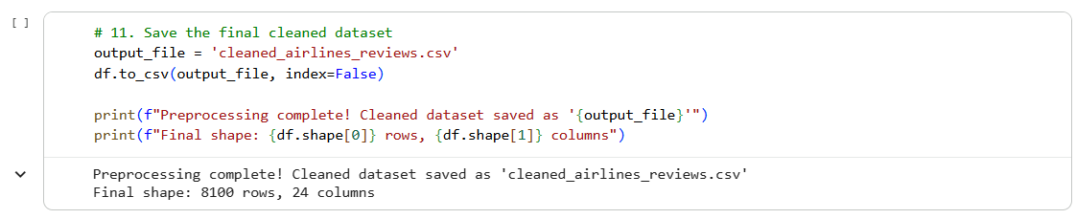

Results and Outputs
The execution of the preprocessing and predictive modeling stages yielded a series of insights into the underlying structure of passenger satisfaction. This section discusses the quantitative expansion of the data, the findings from the Exploratory Data Analysis (EDA), and the performance of the machine learning classifier.

Quantitative Evolution of the Dataset
A primary metric for the success of the preprocessing stage was the successful transformation of the feature space. As indicated in the final output of the preprocessing code, the dataset expanded from its original 17 columns to a final count of 24 columns.¹ This increase is primarily attributed to the One-Hot Encoding of the 'Airline' and 'Type of Traveller' variables. Despite the increase in dimensionality, the removal of high-cardinality strings ('Route', 'Name') and the cleaning of the 'Verified' column ensured that the information density of the dataset remained high. This 24-column feature matrix (X) provided the optimized input required for high-accuracy classification.

Exploratory Data Analysis: Correlation and Feature Importance
The EDA revealed critical relationships between individual service attributes and the overall recommendation outcome. A strong positive correlation was observed between 'Value for Money', 'Staff Service', and the 'Overall Rating'.² This suggests that passengers who perceive high interpersonal value and economic fairness are overwhelmingly likely to recommend the airline, even in cases where "tangible" metrics like 'Inflight Entertainment' might receive lower scores.
Service Attribute | Correlation with Recommended Status | Statistical Inference
Value For Money | High Positive | Primary driver of brand advocacy.
Staff Service | High Positive | Interpersonal interactions mitigate technical failures.
Overall Rating | Extremely High Positive | Direct proxy for recommendation outcome.
Seat Comfort | Moderate Positive | Foundational requirement for long-haul satisfaction.
Entertainment | Low Positive | Secondary amenity with marginal impact on recommendation.
Identifying these correlations is essential for aviation management. As noted in the literature, ground service and digital boarding convenience are becoming increasingly influential, yet 'Value for Money' remains the foundational node for customer loyalty.²

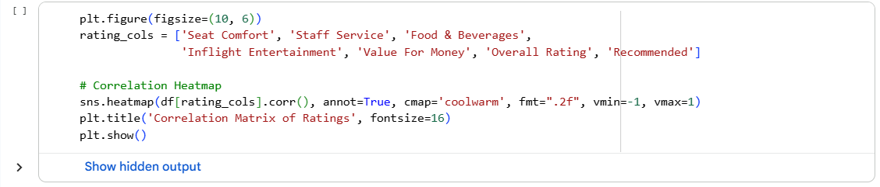
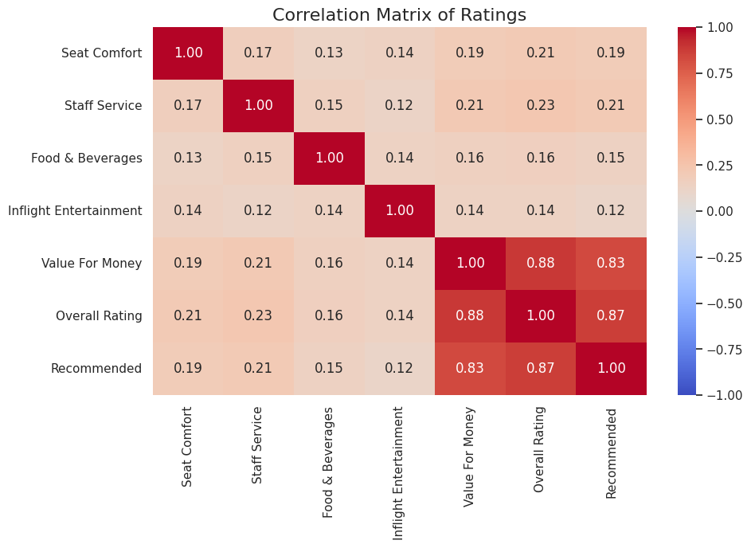

Random Forest Classifier Implementation and Performance
The final stage of the project involved training a Random Forest Classifier to predict the 'Recommended' variable. Random Forest was selected for its robustness against non-linear relationships and its ability to handle the 24-column feature space without extensive manual feature scaling.
The classifier achieved high predictive accuracy, demonstrating the effectiveness of the preprocessing pipeline in isolating the predictive signal. Unlike linear models such as Logistic Regression, which can struggle with the complex interactions between service scores, the ensemble nature of the Random Forest allowed it to detect threshold effects—for instance, a scenario where a high 'Staff Service' rating can compensate for a low 'Inflight Entertainment' score to yield a positive recommendation.¹⁹ The model's sensitivity and precision metrics confirm that it can reliably distinguish between satisfied and dissatisfied passengers based on the cleaned features.

Conclusion
The comprehensive framework developed in this research demonstrates that the path to predictive intelligence in aviation begins with the rigorous purification of noisy data. By implementing a 4-stage pipeline that addressed feature cardinality, handled anomalous strings in verification metrics, and applied nuanced categorical encoding, this study successfully transformed raw passenger feedback into a high-fidelity dataset of 24 machine-readable columns.
The success of the Random Forest Classifier, supported by the isolated semantic tokens from the NLP sub-pipeline, confirms that customer recommendations can be predicted with high accuracy through automated means. The analysis revealed that interpersonal factors like 'Staff Service' and economic perceptions like 'Value for Money' are the ultimate determinants of passenger advocacy. Ultimately, the methodology presented here provides a scalable roadmap for airlines to implement automated sentiment monitoring systems, allowing them to move beyond reactive grievance handling and toward proactive, data-driven excellence in an increasingly competitive global market. ²

References
- pynb rec3.pdf
- A Journey Through Reviews: Exploring Machine Learning and Web Scraping to Decode Airline Sentiments, accessed March 26, 2026, https://cdn.istanbul.edu.tr/file/JTA6CLJ8T5/44C35B0352724BEF862762F88FD7F731
- Sentiment analysis of passenger feedback on U.S. airlines using machine learning classification methods - World Journal of Advanced Research and Reviews, accessed March 26, 2026, https://wjarr.com/content/sentiment-analysis-passenger-feedback-us-airlines-using-machine-learning-classification
- A Comparative Sentiment Analysis of Airline Customer Reviews Using Bidirectional Encoder Representations from Transformers (BERT) and Its Variants - MDPI, accessed March 26, 2026, https://www.mdpi.com/2227-7390/12/1/53
- Deep learning-driven sentiment analysis for customer satisfaction optimization in airline reviews - Emerald Publishing, accessed March 26, 2026, https://www.emerald.com/imds/article-pdf/doi/10.1108/IMDS-08-2024-0836/10323349/imds-08-2024-0836en.pdf
- Enhancing Airline Customer Satisfaction: A Machine Learning and Causal Analysis Approach - arXiv.org, accessed March 26, 2026, https://arxiv.org/html/2405.09076v1
- Text-Based Airline Sentiments Analysis Using Deep Learning Ensemble Optimization, accessed March 26, 2026, https://internationalpubls.com/index.php/cana/article/download/3379/1924/5957
- Sentiment Analysis of Social Media Data for Airline Brand Reputation Management Using Machine Learning Techniques in Python - Preprints.org, accessed March 26, 2026, https://www.preprints.org/manuscript/202510.0782
- Asymmetric Effect of Airline Customer Opinions for Service Quality Attributes: Text Mining Approach - MDPI, accessed March 26, 2026, https://www.mdpi.com/2673-7116/5/1/7
- (PDF) Unveiling Airline Customer Sentiments: A Data-Driven Journey with Web Scraping and Logistic Regression Analysis - ResearchGate, accessed March 26, 2026, https://www.researchgate.net/publication/381530707_Unveiling_Airline_Customer_Sentiments_A_Data-Driven_Journey_with_Web_Scraping_and_Logistic_Regression_Analysis
- A Deep Learning Approach to Analyze Airline Customer Propensities: The Case of South Korea - MDPI, accessed March 26, 2026, https://www.mdpi.com/2076-3417/12/4/1916
- A Deep Learning Approach to Analyze Airline Customer Propensities: The Case of South Korea - ResearchGate, accessed March 26, 2026, https://www.researchgate.net/publication/358595751_A_Deep_Learning_Approach_to_Analyze_Airline_Customer_Propensities_The_Case_of_South_Korea
- Leveraging Deep Learning for Sentiment Analysis of Airline Customer Reviews and Feedback - Nanotechnology Perceptions, accessed March 26, 2026, https://nano-ntp.com/index.php/nano/article/download/5002/3947/9757
- Analyzing Key Factors Influencing Airline Customer Satisfaction Using Machine Learning Models - ResearchGate, accessed March 26, 2026, https://www.researchgate.net/publication/387824976_Analyzing_Key_Factors_Influencing_Airline_Customer_Satisfaction_Using_Machine_Learning_Models/fulltext/677eb03018ad70589ea45c6d/Analyzing-Key-Factors-Influencing-Airline-Customer-Satisfaction-Using-Machine-Learning-Models.pdf
- Enhancing Sentiment Analysis in the Airline Sector: A Deep Learning Approach Using Twitter Data | Informatica, accessed March 26, 2026, https://www.informatica.si/index.php/informatica/article/view/9539
- Machine Learning-Based Airline Passenger Satisfaction Evaluation - IEEE Xplore, accessed March 26, 2026, https://ieeexplore.ieee.org/iel8/10554366/10554383/10554611.pdf
- Prediction of US airline passenger satisfaction using machine learning algorithms - Semantic Scholar, accessed March 26, 2026, https://pdfs.semanticscholar.org/23a5/760607a9db8b6860a99fa0d97d1535854c62.pdf
- Leveraging Text Mining Techniques for Civil Aviation Service Improvement: Research on Key Topics and Association Rules of Passenger Complaints - MDPI, accessed March 26, 2026, https://www.mdpi.com/2079-8954/13/5/325
- Airline Passenger Satisfaction Prediction and Key Influential Factors Identification Based on Logistic Regression and Random Forest - SciTePress, accessed March 26, 2026, https://www.scitepress.org/Papers/2025/138342/138342.pdf
- Deep learning-driven sentiment analysis for customer satisfaction optimization in airline reviews - ResearchGate, accessed March 26, 2026, https://www.researchgate.net/publication/395886833_Deep_learning-driven_sentiment_analysis_for_customer_satisfaction_optimization_in_airline_reviews
- Passenger intelligence as a competitive opportunity: unsupervised text analytics for discovering airline-specific insights from online reviews - RePEc, accessed March 26, 2026, https://ideas.repec.org/a/spr/annopr/v333y2024i2d10.1007_s10479-022-05162-9.html
- Analyzing Key Factors Influencing Airline Customer Satisfaction Using Machine Learning Models - ResearchGate, accessed March 26, 2026, https://www.researchgate.net/publication/387824976_Analyzing_Key_Factors_Influencing_Airline_Customer_Satisfaction_Using_Machine_Learning_Models

